Maths

Functional Skills

Entry Level 3

Add and subtract
using three
-
digit numbers

v1.0

Maths

Functional Skills

Entry Level 3

Add and subtract
using three
-
digit numbers

v1.0

Functional Skills Maths:
Entry 3

Skill Standard:
1

Coverage and Range:

Add and subtract decimals using three-digit numbers.

- Understand there are different strategies for adding and subtracting, for example 26 + 19 = 26 + 20 – 1 = 45
- Know how to partition numbers, for example 32 + 127 + 6 = 100 + 30 + 20 + 20 + 2 +
7 + 6

Explain the Skill

Addition

You may remember that:

- Number order doesn’t matter in addition. This means that 1+ 2 + 3 equals the same as 3 + 2 + 1

- Add, plus, sum, altogether, total and increase are all different words that are used in addition. They mean the same. And this means that:

  - 3 add 3 equals 6
  - 3 plus 3 equals 6
  - The sum of 3 and 3 is 6
  - 3 and 3 altogether make 6 ▪ The total of 3 and 3 is 6
  - Increase 3 by 3 to get 6.

It is likely that every day you use addition to work out small sums in your head. For example, if you were to work out the total price of a chocolate bar and a drink, each costing 50 pence, it is unlikely you would need to write the sum down. Many people will know that 50 p + 50 p = 100 p or £1.

If you are adding together a more complex sum, then it is handy to know several addition methods to make it easier. These are explained on the following pages.

Addition Using Columns

One way of adding numbers together is to write them out in columns of hundreds, tens and units and add each column.

You must make sure that each figure is in the correct column and lined up accurately.

Example

212 + 325

Set the calculation out in columns. Line up units to units, tens to tens and hundreds to hundreds.

H T U

Add the units together. | e.g. 2 + 5 = 7 units
H T U  Then add the tens together. | e.g. 1 + 2 = 3 tens

H T U

Finally, add the hundreds together. e.g. 2 + 3 = 5 hundreds

H T U

Using Columns

Sometimes when you add up the column of hundreds, tens or units there is a carry over into the next column.

You must make sure that each figure is in the correct column and lined up accurately.

Example

476 + 337

Set the calculation out in columns. Line up units to units, tens to tens and hundreds to hundreds.
H T U
4 7 6 + 3 3 7

Add the units together. e.g. 6 + 7 = 13

H T U
4 7 6
+ 3 3 7
Put the 3 in the units column and
3
1 carry the 1 over to the tens column.

Then add the tens together. e.g. 7 + 3 + (the carry over figure, 1) = 11

H T U
4 7 6
+ 3 3 7
Put the 1 in the tens column and 1 3
1 1 carry 1 over to the hundreds column.

Finally, add the hundreds together. e.g. 4 + 3 + (the carry over figure, 1) = 8

H T U
4 7 6
+
3

3

7

8 1 3

1 1

Addition Counting On

You can add numbers together by ‘counting on’.

Examples

2 + 17 Swap the numbers around so the bigger number is first.

17 + 2 Start with 17 then count on 2 numbers, e.g. 18, 19.

Partitioning

Another way of working out an addition sum, the partition method involves you splitting numbers into hundreds, tens and units, and adding them separately, before putting them together for the final answer. For example:

254 + 306

• Firstly, separate the hundreds, tens and units…

HTU HTU

256 + 304

Hundreds: 200 + 300
Tens: 50 + 0 Units: 6 + 4
- Next, add the individual parts…

200 + 300 = 500
50 + 0 = 50
6 + 4 = 10

- Finally, add the different parts together for the answer…

500 + 50 = 550
550 + 10 = 560

- So the answer to the sum is:

256 + 304 = 560

– Number Line

Using a number line can help you work out a difficult addition sum. For example:

HTU HTU
144 + 231

- First, start at the largest number and partition the small number into hundreds, tens and units.

231 + 100 + 40 + 4

- Then, follow each step of the sum along the number line.
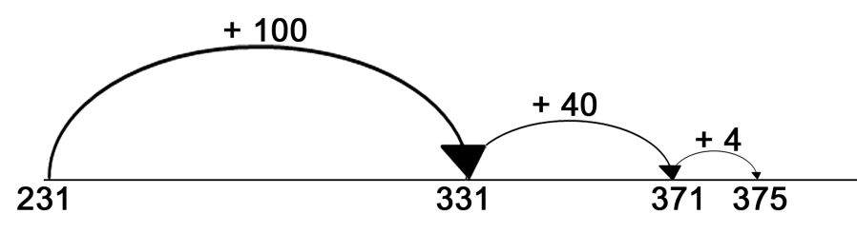

- Mental Addition

There are many different methods to use when adding up in your head. Generally, use whatever method you know already. For instance:

- Number bonds up to 10. (Pairs of whole numbers that make up 10), for example:

5 + 5 = 10
4 + 6 = 10
3 + 7 = 10
2 + 8 = 10
1 + 9 = 10

- Count on in tens and then add the units.

Examples

14 + 36 Using number bonds. 4 + 6 = 10 10 + 30 = 40 40 + 10 = 50

325 + 45 Count on in tens then add the units. 325 + 10 + 10 + 10 + 10 = 365 + 5 = 370 Practise the Skill

- Match the questions to their correct answers:

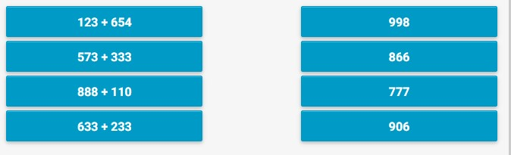

- You get a weekend job at a local music shop. In the stock room, there are 543 CDs and 446 DVDs. How many are there all together?

- A sale is on at the shop. In the sale there are 356 albums and 232 singles, all of them are CDs. How many CDs are in the sale?

- At the music shop, a band is doing a record signing with the public. In the morning 256 people come. In the afternoon 432 people come. How many people came to see the band altogether?

- The shop sells band posters. Look at the sales below:

  - Poster A: 387
  - Poster B: 293

What is the total number of posters sold?

- The next week at the shop is very busy. Complete the table below to work out how many CDs were sold:

Monday | 142
Tuesday | 153
Wednesday | 235
Total

Explain the Skill

Subtraction

You may remember that:

- Number order does matter in subtraction. This means that 6 – 4 and 4 – 6 will give completely different answers.

- Subtract, reduce, take away, difference, decrease, minus, less than, are all words used in subtraction. They mean the same. And this means that:

  - Subtract 4 from 6 is 2
  - Reduce 6 by 4 is 2

▪ 6 take away 4 is 2
- The difference between 6 and 4 is 2
- Decrease 6 by 4 is 2
- 6 minus 4 is 2

▪ 4 is 2 less than 6

Like addition, subtraction is one of the most important mathematical skills you can have.

Again, like addition, it is likely you use subtraction almost every day. Many of the methods you will use are the same, or very similar, to the methods used in addition. These are explained on the following pages.

Subtraction – Partitioning

This method involves you splitting numbers into hundreds, tens and units and subtracting them separately. For example:

225 – 111

- First, separate the hundreds, tens and units…

Hundreds: 200 – 100
Tens: 20 – 10
Units: 5 – 1

- Next, subtract the individual parts…

200 – 100 = 100
20 – 10 = 10
5 – 1 = 4

- Finally, add all these answers together.

100 + 10 + 4 = 114

- So, the final answer is…

225 – 111 = 114

Subtraction - Using Columns

One way of subtracting numbers is to write them out in columns of hundreds, tens and units and subtract each column in turn.

Make sure that you put the two numbers in the correct order. The number that you are taking away is always placed below the original number and so the bottom number is always taken away from the top number.

You must make sure that each figure is in the correct column and lined up accurately.

Example 1

389 - 164

Set the calculation out in columns. Line up units to units, tens to tens and hundreds to hundreds.

H T U
3 8 9
- 1 6 4

Subtract the units e.g. 9 - 4 = 5 units

  - T U
3 8 9
- 1 6 4

5

Then subtract the tens e.g. 8 - 6 = 2 tens

  - T U
3 8 9
- 1 6 4

2 5

Finally, subtract the hundreds e.g. 3 - 1 = 2 hundreds

  - T U
3 8 9
-
1

6

4

2 2 5

Subtraction - Using Columns

The following examples show different methods of calculating the same sum.

Example 2 Method 1

432 - 54

Set the calculation out in columns. Line up units to units, tens to tens and hundreds to hundreds.

H T U
4 3 2 - 5 4

Subtract the units. If the top number is smaller than the bottom, then you must take 1 ten from the tens column and put it with the 2 to make 12 units.

- | H T U  2 1  - 3 2  - 4 |  | In the units column change 2 to 12  and  decrease the top tens figure from 3 to 2  The sum is now 12 – 4 = 8 units
8

Then subtract the tens. If the top number is smaller than the bottom, then you must take 1 hundred from the hundreds column.

- | H T U  - 1  2  - 3 2  - 4  7 8 |  | In the tens column change 2 to 12 and  decrease the top tens figure from 4 to 3  The sum is now 12 – 5 = 7 tens

Finally, subtract the hundreds.

H T U The sum is now 3 – 0 = 3 hundreds
3
4 3 2
-
5

4

3 7 8

Subtraction - Using Columns

Set the calculation out in columns. Line up units to units, tens to tens and hundreds to hundreds.

Example 3 Method 2

Set the calculation out in columns. Line up units to units, tens to tens and hundreds to hundreds.

H T U
4 3 2 - 5 4

Subtract the units. If the top number is smaller than the bottom, then you must use 1 ten from the tens column.

H T U  1  4 3 2 |  | In the units column change 2 to 12  and  increase the bottom tens figure from 5 to 6
- 5 4 T he sum is now 12 - 4 = 8 units
6 8
7

Then subtract the tens. If the top number is smaller than the bottom, then you must use 1 hundred from the hundreds column.

- | H T U  1 1  - 3 2  - 4  1 6  7 8 |  | In the tens column change 3 to 13  and place the 1 underneath the 4 in the hundreds column.  The sum is now 13 - 6 = 7 tens

Finally, subtract the hundreds.

H T U The sum is now 4 - 1 = 3 hundreds

4 3 2
- 5 4
1
7 8

Subtraction - Counting On

You can easily work out the answers to take away sums by ‘counting on’ from the smaller given number to the larger number.

Examples

18 − 9

The smaller number is 9 so count on 10, 11, 12, 13, 14, 15, 16, 17, 18.
How many numbers did you count? 10, 11, 12, 13, 14, 15, 16, 17 and 18 = 9 numbers.

Subtraction – Number Line

Similar to addition, a number line can be used for subtraction. With the subtraction method, you move from right to left, instead of left to right. For example:

243 – 112

- First, start with larger number and partition the smaller number into hundreds, tens and units.

243 – 100 – 10 – 2

- Then follow each step of the sum along the number line.

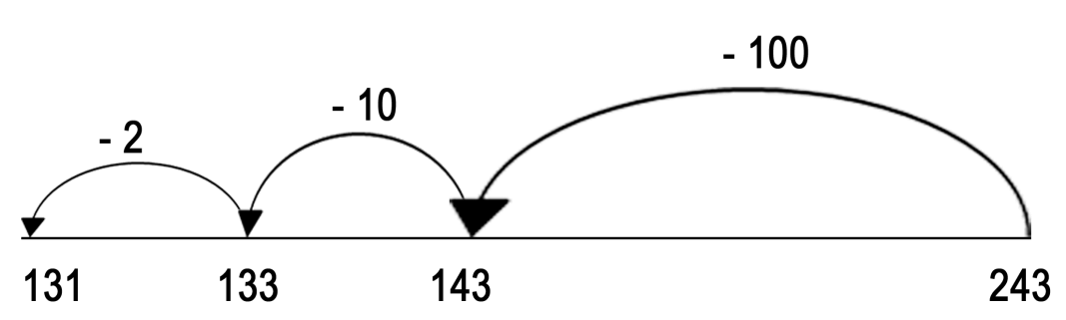

Practise the Skill

- Select the correct answer for the following:

353 – 212 = | a. 143 | b. 200 | c. 141
886 – 483 = | a. 480. | b. 403 | c. 436
704 – 504 = | a. 300 | b. 200 | c. 204

- There are 215 posters in the shop at the start of the week. By Friday, 69 have been sold. How many are left?

- At the end of each week you are paid £279. You spend £27 on bus fares. How much do you have left?

- At the end of the month 750 CDs have been sold. There were 962 in stock at the start of the month. How many are left now?

- On Monday, 355 people visit the shop. On Tuesday, 210 people visit. What is the difference between the Monday and Tuesday?

- On Wednesday, 280 people visit the shop. On Thursday, 290 people visit. What is the difference between the Wednesday and the Thursday?

- The shop sells 740 CDs on Monday and 331 CDs on Tuesday. What is the difference in sales between the two days?

- The shop made £890 on Saturday. However, there is a £120 staff bill. How much profit is left?

£…………

Apply the Skill

- A customer buys several items from The Music Shop. Their receipt is shown below:

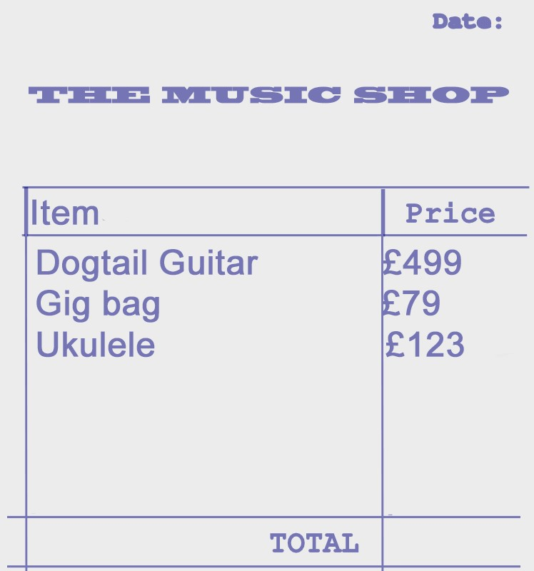

What is the total cost of all three items on the receipt?

£…………

- The cost of 20 ukulele lessons is £187. A customer is accidently charged £350. How much should they be refunded?

£…………

- A guitar costs the shop £120. They sell it for £209. What is the difference in price?

£…………
- You are asked to put up a display in the shop.

The display takes up 150 cm of space. The space for the display is 185 cm. How much space will be left over?

- A customer is interested in music lessons. The prices listed below are for 10 lessons:

  - Guitar - £73

  - Clarinet - £95

  - Violin - £67

  - Drums - £92

They decide to buy guitar and violin lessons. How much will it cost in total?

£…………

- Price up the following bundles:

Guitar: £89
Amp: £140
Leads: £33

How much will this bundle cost to buy?

£…………

Guitar: £325
Amp: £278
Gig case: £121

How much will this bundle cost to buy?

£…………

- The Mega-star bundle costs £989. A customer has a voucher for £299. How much will the bundle cost them now?

£…………

QCA Functional Skills guidance: amplification of the standards June 2008 QCA/08/3700

